

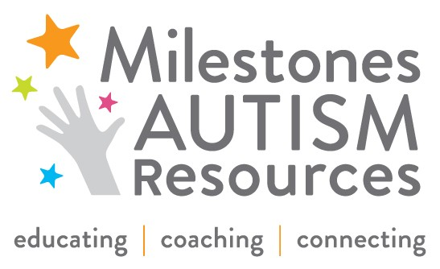
FOR IMMEDIATE RELEASE
DATE: 4/29/2015

CONTACT: Mike Brickner PHONE: 216.464.7600
EMAIL: mbrickner@acluohio.org

CONTACT: Peggy Zone Fisher PHONE: 216.752.3000
EMAIL: pzfisher@diversitycenterneo.org

CONTACT: Ilana Hoffer Skoff PHONE: 216.464.7600
EMAIL: hskoff@milestones.org

ACLU of Ohio, The Diversity Center of Northeast Ohio & Milestones Autism Resources Appalled by Violence Against Child with Autism in Cleveland The organizations call for a full investigation

Cleveland, OH-­‐ The ACLU of Ohio, The Diversity Center of Northeast Ohio and Milestones Autism Resources are appalled by the treatment of a child with autism spectrum disorder in Cleveland. Acts of violence of this nature are completely unacceptable. This horrific act highlights the need for autism awareness and acceptance. We hope this terrible event is an opportunity to discuss the importance of recognizing that every individual has something to contribute and to celebrate differences that add value to our community.

Autism now affects 1 in 68 people. Not even a year ago, Northeast Ohio captured national attention because of the offensive and cruel acts committed against a local high school student with autism in Bay Village. Now, we have a child with autism being brutally assaulted while an adult onlooker and the parent of the attacker encouraged and filmed the attack. As a community we need to not only raise awareness about autism and how it impacts an individual, but also encourage acceptance by creating inclusive communities that value every person.

Although these horrendous acts cannot be undone, we ask for a thorough investigation that results in justice being served. Education is an incredibly important component in creating a sustainable community culture of respect and inclusion. Our organizations work tirelessly in Northeast Ohio to address issues such as this. We offer our support and experience to anyone in need following this unfortunate event.

About Milestones Autism Resources
Founded in 2003, Milestones Autism Resources, improves the lives of individuals on the autism spectrum, by educating, coaching and connecting the autism community with evidence-­‐based information. We envision a community in which individuals on the autism spectrum reach their full potential as contributing members of society, recognized for their strengths and supported in their challenges. Milestones serves over 3,000 parents, professionals, and individuals of all ages and abilities, through an annual conference and coaching services. The website milestones.org connects 55,000 unique visitors to more than 1,000 autism resources.

About The Diversity Center of Northeast Ohio
Founded in 1927 as the National Conference of Christians and Jews, The Diversity Center of Northeast Ohio works to eliminate bias, bigotry, and racism through education and advocacy. The Diversity Center empowers individuals to build on the strength of diversity and to create communities where all people are connected, respected, and valued. Its goal is to help individuals and organizations develop the necessary tools to recognize, understand, appreciate, leverage, and celebrate diversity.

About the ACLU of Ohio
The ACLU of Ohio is an affiliate of the national ACLU. Founded in 1920, the national ACLU includes more than 500,000 members in all 50 states, making it our country’s foremost advocate of individual rights. The ACLU of Ohio has nearly 30,000 members and supporters statewide. Through education, litigation, and lobbying the ACLU seeks to preserve civil liberties for each new generation.

###

