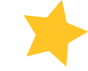
JUMP INTO SPRING WITH SOAR!

GET MOVING AND JOIN THE FUN TODAY!

(APRIL 6th – MAY 14th)

Join us for the next session of SOAR! activities! In addition to the relaxing walking programs in the Metroparks and Brooklyn Memorial Park, meet us at the beautiful Gemini Center in Fairview Park for our Monday night dancercize and Saturday evening volleyball classes. Or, join our ever popular aerobics class on Wednesdays at Big Creek Center……There’s something for everyone so sign up today!
MONDAYS | TUESDAYS |  |  | WEDNESDAYS |  | THURSDAYS |  | SATURDAYS
DANCERCIZE: 6:30 – 7:30PM  Where: Gemini Center,  21225 Lorain Road  (Just West of 210th Street) | WALKING: 6:30-7:30 PM  Where: Rocky River Reservation,  Rockcliff Spring Parking lot. (1¼  miles south of Detroit Road park entrance) |  |  | AEROBICS: 6:30 – 7:30 PM  Where: Big Creek Center (6149 West 130th Street) |  | WALKING: 6:30 – 7:30 PM  Where: Brooklyn Memorial Park (7727 Memphis Avenue) |  | SEATED VOLLEYBALL:  5:30 – 7:00 PM  Where: Gemini Center, (21225 Lorain Road)
Description: Join Dee and your SOAR! staff for a fantastic hour of moving and grooving. We’ll work out those winter aches and pains and a fun time will be had by all!  Limited to 35 participants | Description: Time to rejoin the great outdoors and enjoy the crisp Spring air! We’ll walk on the paved path and enjoy the company of friends!  Limited to 30 participants |  |  | Description: Join this popular activity with Angie. Listen to great tunes while we work on strength, endurance & flexibility. Always a great time… see you there!  Limited to 45 participants |  | Description: Stroll through the beautiful, paved, Memorial Park setting for a wonderful evening out! Perfect for walkers, wheelchairs and anyone that wants to join in!  Limited to 30 participants |  | Description: Join us for an evening of seated volleyball. We’ll use a beach ball to test your VB skills. Ideal for wheelchairs and promises lots of fun & laughs!  Limited to 26 participants
Dates: April 6th, 13th, 20th,27th  May 4th & 11th | Dates: April 7th, 14th, 21st,28th  May 5th & 12th |  |  | Dates: April 8th, 15th, 22nd,29th  May 6th & 13th |  | Dates: April 9th, 16th, 23rd,30th  May 7th & 14th |  | Dates: April 11th, 18th, 25th  May 2nd
Fee: $20. | Fee: $12. |  |  | Fee: $20. |  | Fee: $12. |  | Fee: $20.
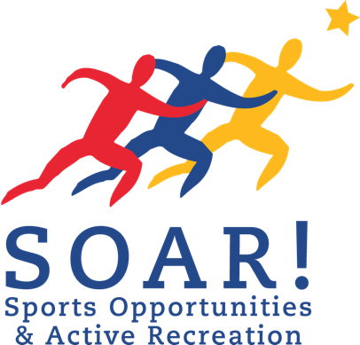
(Fee includes: snacks at each activity)

Registration Deadline is Friday, March 27th, so sign up today!!!

FOR ADDITIONAL INFORMATION OR TO REGISTER FOR AN ACTIVITY CALL US AT: (440) 327-6454

Mail completed *form and registration fee to: SOAR!, 4937 Mills Industrial Parkway, North Ridgeville, Ohio 44039
*If not on file for the current year

