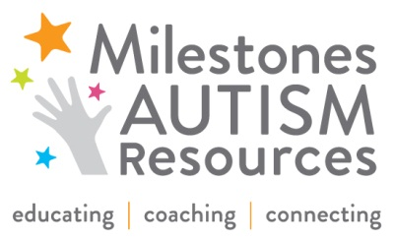

FOR IMMEDIATE RELEASE
DATE: 10/22/2015
CONTACT: Allison Peterson, O: 216.464.7600 x111, C: 440.376.5171, agpeterson@milestones.org

NEWS RELEASE

December 5 - “Raise Your Hands For Milestones Autism Resources” Benefit

CLEVELAND – Milestones Autism Resources, a nonprofit dedicated to educating, coaching, and connecting family members and professionals throughout Northeast Ohio affected by autism, announces its annual benefit “Raise Your Hands For Milestones” on Saturday, December 5, at 7 p.m. at Cleveland Marriott East (26300 Harvard Road, Warrensville Heights). Patron tickets are $500 ($410 tax deductible) and regular tickets are $200 ($110 tax deductible); tickets are available at milestones.org. RSVP is encouraged by November 13. Proceeds from the event directly support local families impacted by autism.

This year, Milestones will honor Joyce Goldberg Fromson, Andrea Kanter Grodin, and Donna Yanowitz to recognize their board leadership and extraordinary service. “I support Milestones because they provide hands-on resources and support to families right here in the Cleveland area,” said Fromson.

Honorary Chairs are Allison & Tom Frazier, Cathy & Larry Goldberg, Diane & Steve Rosen, Kyla & Mitchell Schneider, Barbara & Jon Shane, Margaret & Larry Singerman, Judy & Steve Willensky, and Dara & Alan Yanowitz.

For more information about tickets or advertising opportunities, please visit milestones.org.

# # #

About Milestones Autism Resources
Founded in 2003, Milestones Autism Resources improves the lives of individuals on the autism spectrum throughout Northeast Ohio by educating, coaching, and connecting the autism community with evidence-based information. Milestones is the first call for help at each transition of an individual’s life. Milestones envisions a community in which individuals on the autism spectrum reach their full potential as contributing members of society, recognized for their strengths and supported in their challenges. Each year, Milestones serves more than 3,100 parents, professionals, and individuals of all ages and abilities, through an annual conference, trainings, and coaching services. The website, milestones.org, connects 55,000 unique visitors to more than 1,000 autism resources.

